ROMEO NXUMALO

25/SCA/BCDS/O21

DATA STRUCTURES MINI-PROJECT

TOPIC: Species Habitat & Pollution Tolerance Project Report

Species Habitat & Pollution Tolerance Management System
1. Introduction
This project is a simple data structures-based application developed in C. It allows users (students) to store and manage information about different species, their habitats, and their pollution tolerance levels. The system uses a singly linked list for dynamic data storage and demonstrates concepts such as insertion, traversal, and categorization.

2. Objective
- To implement a linked list in C
- To store species, habitat, and pollution tolerance
- To group and display species based on tolerance levels
- To visualize data using a simple text-based graph

3. Theory
🔹 Linked List
A linked list is a linear data structure where elements are stored in nodes. Each node contains:
- Data
- A pointer to the next node
Advantages:
- Dynamic memory allocation
- Efficient insertion and deletion
🔹 Types Used
- Singly Linked List

🔹 Operations Performed
- Insertion (at end)
- Traversal
- Grouping based on category
- Counting nodes
4. Data Structure Design
Each node contains:
- Species Name
- Habitat
- Pollution Tolerance (Low/Medium/High)
- Pointer to next node

5. Algorithm
➤ Algorithm: Insert Species
- Create a new node
- Assign species name, habitat, and tolerance
- If list is empty → make it head
- Else traverse to last node
- Link new node at the end
➤ Algorithm: Display All Species
- Start from head
- Traverse until NULL
- Print each node's data

➤ Algorithm: Group by Pollution Tolerance
- Define categories: Low, Medium, High
- For each category:
  - Traverse list
  - Print matching nodes
➤ Algorithm: Display Graph
- Initialize counters (low, medium, high)
- Traverse list
- Increment respective counters and Print stars (*) based on counts

6. Program Code
#include <stdio.h>
#include <stdlib.h>
#include <string.h>

// Structure definition
struct Species {
char name[50];
char habitat[50];
char tolerance[10]; // Low, Medium, High
struct Species* next;
};

struct Species* head = NULL;

// Create new node
struct Species* createNode(char name[], char habitat[], char tolerance[]) {
struct Species* newNode = (struct Species*)malloc(sizeof(struct Species));
strcpy(newNode->name, name);
strcpy(newNode->habitat, habitat);
strcpy(newNode->tolerance, tolerance);
newNode->next = NULL;
return newNode;
}

// Insert at end
void insertSpecies(char name[], char habitat[], char tolerance[]) {
struct Species* newNode = createNode(name, habitat, tolerance);

if (head == NULL) {
head = newNode;
return;
}

struct Species* temp = head;
while (temp->next != NULL) {
temp = temp->next;
}
temp->next = newNode;
}

// Display grouped by tolerance
void displayGrouped() {
struct Species* temp;

char* levels[] = {"Low", "Medium", "High"};

printf("\n=== Species Grouped by Pollution Tolerance ===\n");

for (int i = 0; i < 3; i++) {
temp = head;
printf("\n%s Tolerance:\n", levels[i]);

int found = 0;
while (temp != NULL) {
if (strcmp(temp->tolerance, levels[i]) == 0) {
printf("Species: %s | Habitat: %s\n",
temp->name, temp->habitat);
found = 1;
}
temp = temp->next;
}

if (!found) {
printf("No species found.\n");
}
}
}

// Display all data
void displayAll() {
struct Species* temp = head;

if (temp == NULL) {
printf("No data available.\n");
return;
}

printf("\n--- All Species Data ---\n");
while (temp != NULL) {
printf("Name: %s | Habitat: %s | Tolerance: %s\n",
temp->name, temp->habitat, temp->tolerance);
temp = temp->next;
}
}

// Load sample data
void loadDefaultData() {
insertSpecies("Frog", "Wetlands", "Low");
insertSpecies("Pigeon", "Urban", "High");
insertSpecies("Fish", "River", "Medium");
insertSpecies("Lichen", "Forest", "Low");
insertSpecies("Cockroach", "Urban", "High");
}

// Main function
int main() {
int choice;
char name[50], habitat[50], tolerance[10];

loadDefaultData();

while (1) {
printf("\n====== Species Management System ======\n");
printf("1. Add Species\n");
printf("2. Display All Species\n");
printf("3. Display Grouped by Pollution Tolerance\n");
printf("4. Exit\n");
printf("Enter choice: ");
scanf("%d", &choice);

switch (choice) {
case 1:
printf("Enter Species Name: ");
scanf("%s", name);
printf("Enter Habitat: ");
scanf("%s", habitat);
printf("Enter Pollution Tolerance (Low/Medium/High): ");
scanf("%s", tolerance);
insertSpecies(name, habitat, tolerance);
printf("✔ Species Added Successfully!\n");
break;

case 2:
displayAll();
break;

case 3:
displayGrouped();
break;

case 4:
printf("Exiting...\n");
exit(0);

default:
printf("Invalid choice!\n");
}
}

return 0;
}

7. Sample Output
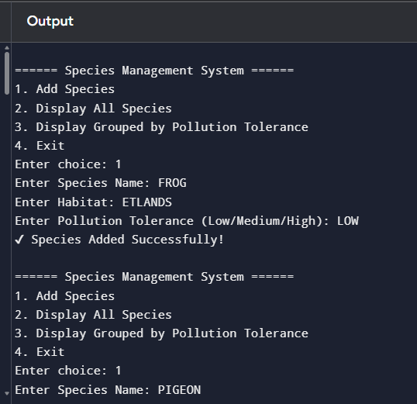
➤ Display All Species
Name: Frog | Habitat: Wetlands | Tolerance: Low
Name: Pigeon | Habitat: Urban | Tolerance: High
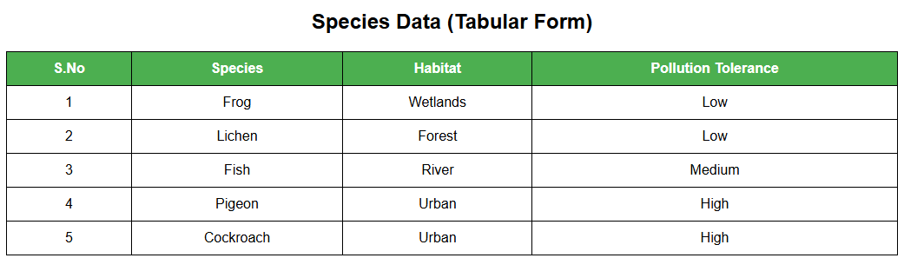

➤ Grouped Output
Low Tolerance:
Frog, Lichen
Medium Tolerance:
Fish
High Tolerance:
Pigeon, Cockroach
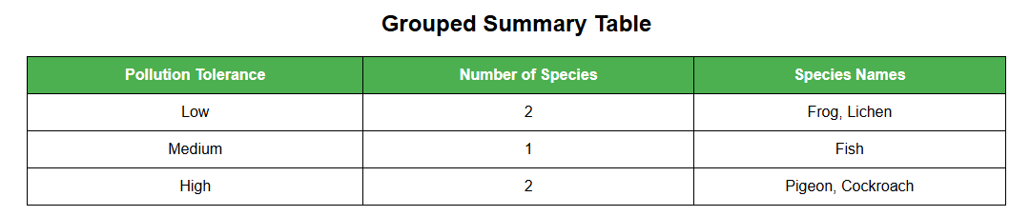

➤ Graph Output
Low (2): **
Medium (1): *
High (2): **

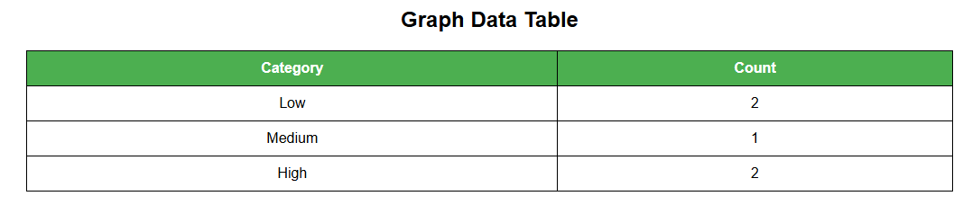
Low (2): **
Medium (1): *
High (2): **
8. Applications
- Environmental studies
- Pollution monitoring systems
- Educational tools
- Biodiversity tracking

9. Advantages
- Easy to implement
- Efficient memory usage
- Dynamic data handling

10. Limitations
- No permanent storage (no file handling)
- Case-sensitive input
- Console-based interface only

11. Future Enhancements
- Add file handling
- GUI implementation
- Sorting and searching
- Integration with environmental sensors

12. Conclusion
This project successfully demonstrates the use of linked lists in managing ecological data. It provides a simple yet effective way to categorize species based on pollution tolerance and visualize the results using a text-based graph.

